**APEX Hospital Management**

**Software Requirements Specification Document**

**Name: Chebrolu Rukmini**

**RollNO: AP18110010298**

**Sec: CSE-E**

**1.Introduction**

The main objective of the Apex Hospital management is to help the Manager of the hospital by automating the system, so that he/she can check all the requirements if required. This system contains and manages the information/ Bio-Data of all the Patients, Doctors, Nurses and other helping staff. The purpose of the project is to construct an application program for managing and storing the information, Bio-Data, details, Billings, records and all the process happening in the Hospital, Which will be useful to reduce the manual work.

**1.1 Abstract**

This Management System is a system java-programming based project that serves the activities of all the individuals in the hospital including patients. The system helps the management to get the information and symptoms of the patient and direct them to the respective doctor. The respective doctor will prescribe medicines to the patient by nurses, finally the patients can get their medicines and bills for the individuals from the helping staff. Also this system can appoint new Doctors, Nurses and other helping staff.

**1.2 Purpose**

The purpose of this java-programming system can be implemented in the hospital where the manager of the management can easily work and get the details and data of all individuals in the Apex hospital and also in other hospitals for their respective needs.

**1.3 Intended audience and reading suggestions**

This document is mainly intended for the people who are involved in the development, testing, operation, maintenance and quality assurance of the system. This also helps users and clients in understanding the requirements of the system. Audiences need not follow any particular order while reading the document and they are free to move to any section which they find relevant to them.

**1.4 Project Scope**

This java-programming based Apex Hospital Management system is a creative and also created in a innovative way, where the management of hospital can easily maintain the records of all individual departments and members, where this will be a hard and huge process while doing this process in manual, also it is a tedious job. This system can make the management stress free from the above process. This system makes the management handle/ review records easily and perfectly. Also, on the patient's side they can easily know the path that they should go and get crossed from the treatments.

**1.5 Definitions, Acronyms, and Abbreviations**

SRS - Software Requirements Specification

HMS - Hospital Management System

**1.6 Overview**

The SRS is organized into two main sections. The first is The Overall Description and the second is the Specific Requirements. The Overall Description will describe the requirements of the Apex HMS from a general high-level perspective. The Specific Requirements section will describe in detail the requirements of the system.

**2. Overall Description**

**2.1 Product Perspective**

The Apex hospital Management system would be a java application, through which Manager/Admin can easily add the data of doctors, Nurses, Helping staff and also doctors can add Patients data easily online instead of writing in books. It can be accessed through any operating system like Windows, MAC, Linux etc., All data for the Apex Hospital will be configured using Java. These data includes Doctors details, patients details, nurses details and other helping staff.

**2.1.1 Hardware Interfaces**

Operating system: Windows/ Linux/ Mac/ any other

Processor: i3 or above

Hard Disk Space: 124MB (min) for JRE

RAM Memory: 128MB (Min)

JRE System Library need to import in Eclipse IDE

**2.1.2 Software Interfaces**

Eclipse IDE - for writing and running code

**2.2 Product Features and Characteristics**

The Apex hospital system provides the functionalities for the Manager/Admin to Add Details

Such as:

1. Manager can Add Doctors Records, Nurses data, Helping Staff
2. Doctors and nurses can add the data of patients
3. Doctors can view the records of their own and also Patients, Nurses, Helping Staff data
4. Patients can see their own records

**2.3 Operating Environment**

**Java:** Java is a class-based, object-oriented programming language and is designed to have as few implementation dependencies as possible. A general-purpose programming language made for developers to write once run anywhere that is compiled java code can run on all platforms that support java. Java applications are compiled to bytecode that can run on any Java Virtual Machine.

# **3.** **SYSTEM FEATURES**

# **3.1** **FUNCTIONAL REQUIREMENTS:**

This is how the application will appear and function until it has been successfully completed. The functional criteria must be met by the system are as follows:

**1. Admin/ Manager:**

* Admin can be having user interface choice like
* Add Details of doctors
* Add Data of nurses
* Add data of Helping staff

**2. Patients:**

* Patients can able to see their own records
* Patients can not see others data

**3. Doctors:**

* Doctors can see only their own records
* Doctors can see patients data
* Doctors can see Nurses data
* Doctors can see other helping staff data
* Doctors can add Patients Data

**4. Nurses:**

* Nurse adds patients records
* And can monitor the health condition of the patients and can give updates to the doctor.

**5. Helping staff:**

* Helping staff will help the hospital to get hospital bill of a patient
* Helping staff will help the hospital to get medicine bill of a patient
* Helping staff will help the hospital wherever needed

# **3.2** **NON-FUNCTIONAL REQUIREMENTS:**

# A non-functional requirement is a requirement that specifies criteria that can be used to judge the operation of a system, rather than specific behaviors.

Some of the non-functional requirements include:

* Scalability
* Capacity
* Availability
* Reliability
* Recoverability
* Maintainability
* Serviceability
* Security
* Regulatory
* Manageability
* Environmental
* Data Integrity

**3.2.1 PERFORMANCE REQUIREMENTS:**

Performance requirements define acceptable response times for system functionality.

● Performance should be fast.

● Performance will depend up on hardware components

● The load time for user interface screens shall take no longer than two seconds.

**3.2.2** **SAFETY REQUIREMENTS**

● Data in the database of the system should not be lost or damaged.

● The source code developed for this system shall be maintained in the configuration Management tool.

● If there is extensive damage to a wide portion of the data due to some failure, such as a disk crash, the recovery method restores a past copy of the data that was backed up to archival storage and reconstructs a more current state by reapplying or redoing the operations of committed processes from the backed-up log, up to the time of failure.

**3.2.3** **SECURITY REQUIREMENTS**

● Secure access of confidential data.

● The whole system is secured. Only the admin can add the data of doctors, nurses, helping staff so that it can't include fake details.

**3.2.4** **SOFTWARE QUALITY ATTRIBUTES**

**Availability:**

The apex hospital management will be available to users at any time except when the space is not sufficient or when having some errors.

**Robustness:**

If the connection between admin and the application is broken or disconnected prior admin can't add the details of doctors, nurses, and helping staff.

**Platform Independence:**

The system must have to run on different platforms and support different types of operating systems.

**Extensibility:** The system must be easy to extend to provide new capabilities.

**4. External Interface Requirements**

**4.1 User Interface**

The system has to allow the Admin/manager to interact with different modules such as adding doctors, nurses and helping staff. Maintaining the records of patients, assigning the doctor to the patients. And viewing the patients, doctors, nurses data.

**4.2 Hardware Interfaces**

A laptop having any operating system. To deploy, the project administrator should have a system with a minimum of 128MB ram and 124Mb disk space for JRE and windows server.

**4.3 Software Interfaces**

The system shall interface with a java(eclipse) for adding, viewing and getting the data. Data is stored related to doctors,patients,nurses and staff.

**4.4 Communicational Interfaces**

The system will show the details of patients and also which doctor is taking care of which patient to the manager.

**5. UML Diagrams**

**5.1 USe Case Diagram**

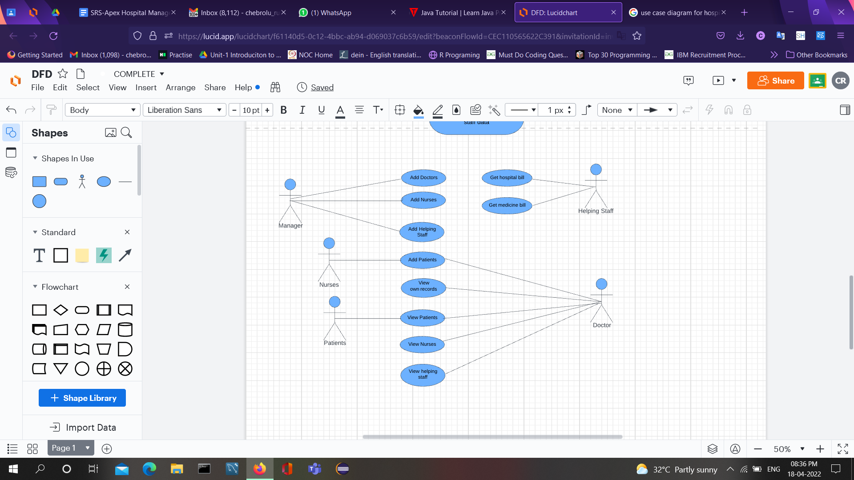

**5.2 Class Diagram**

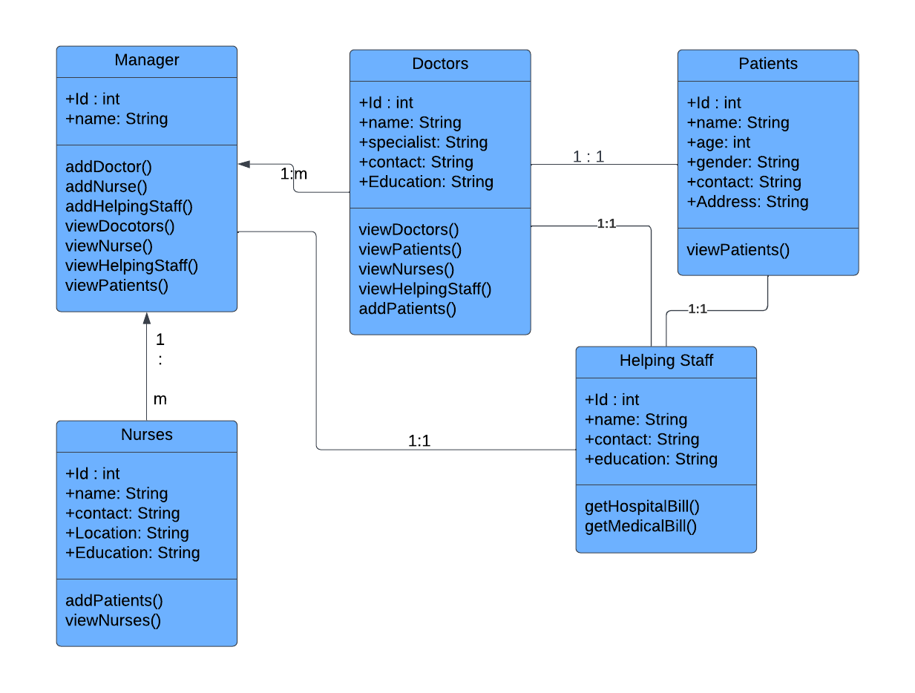

**5.3 Activity Diagram**

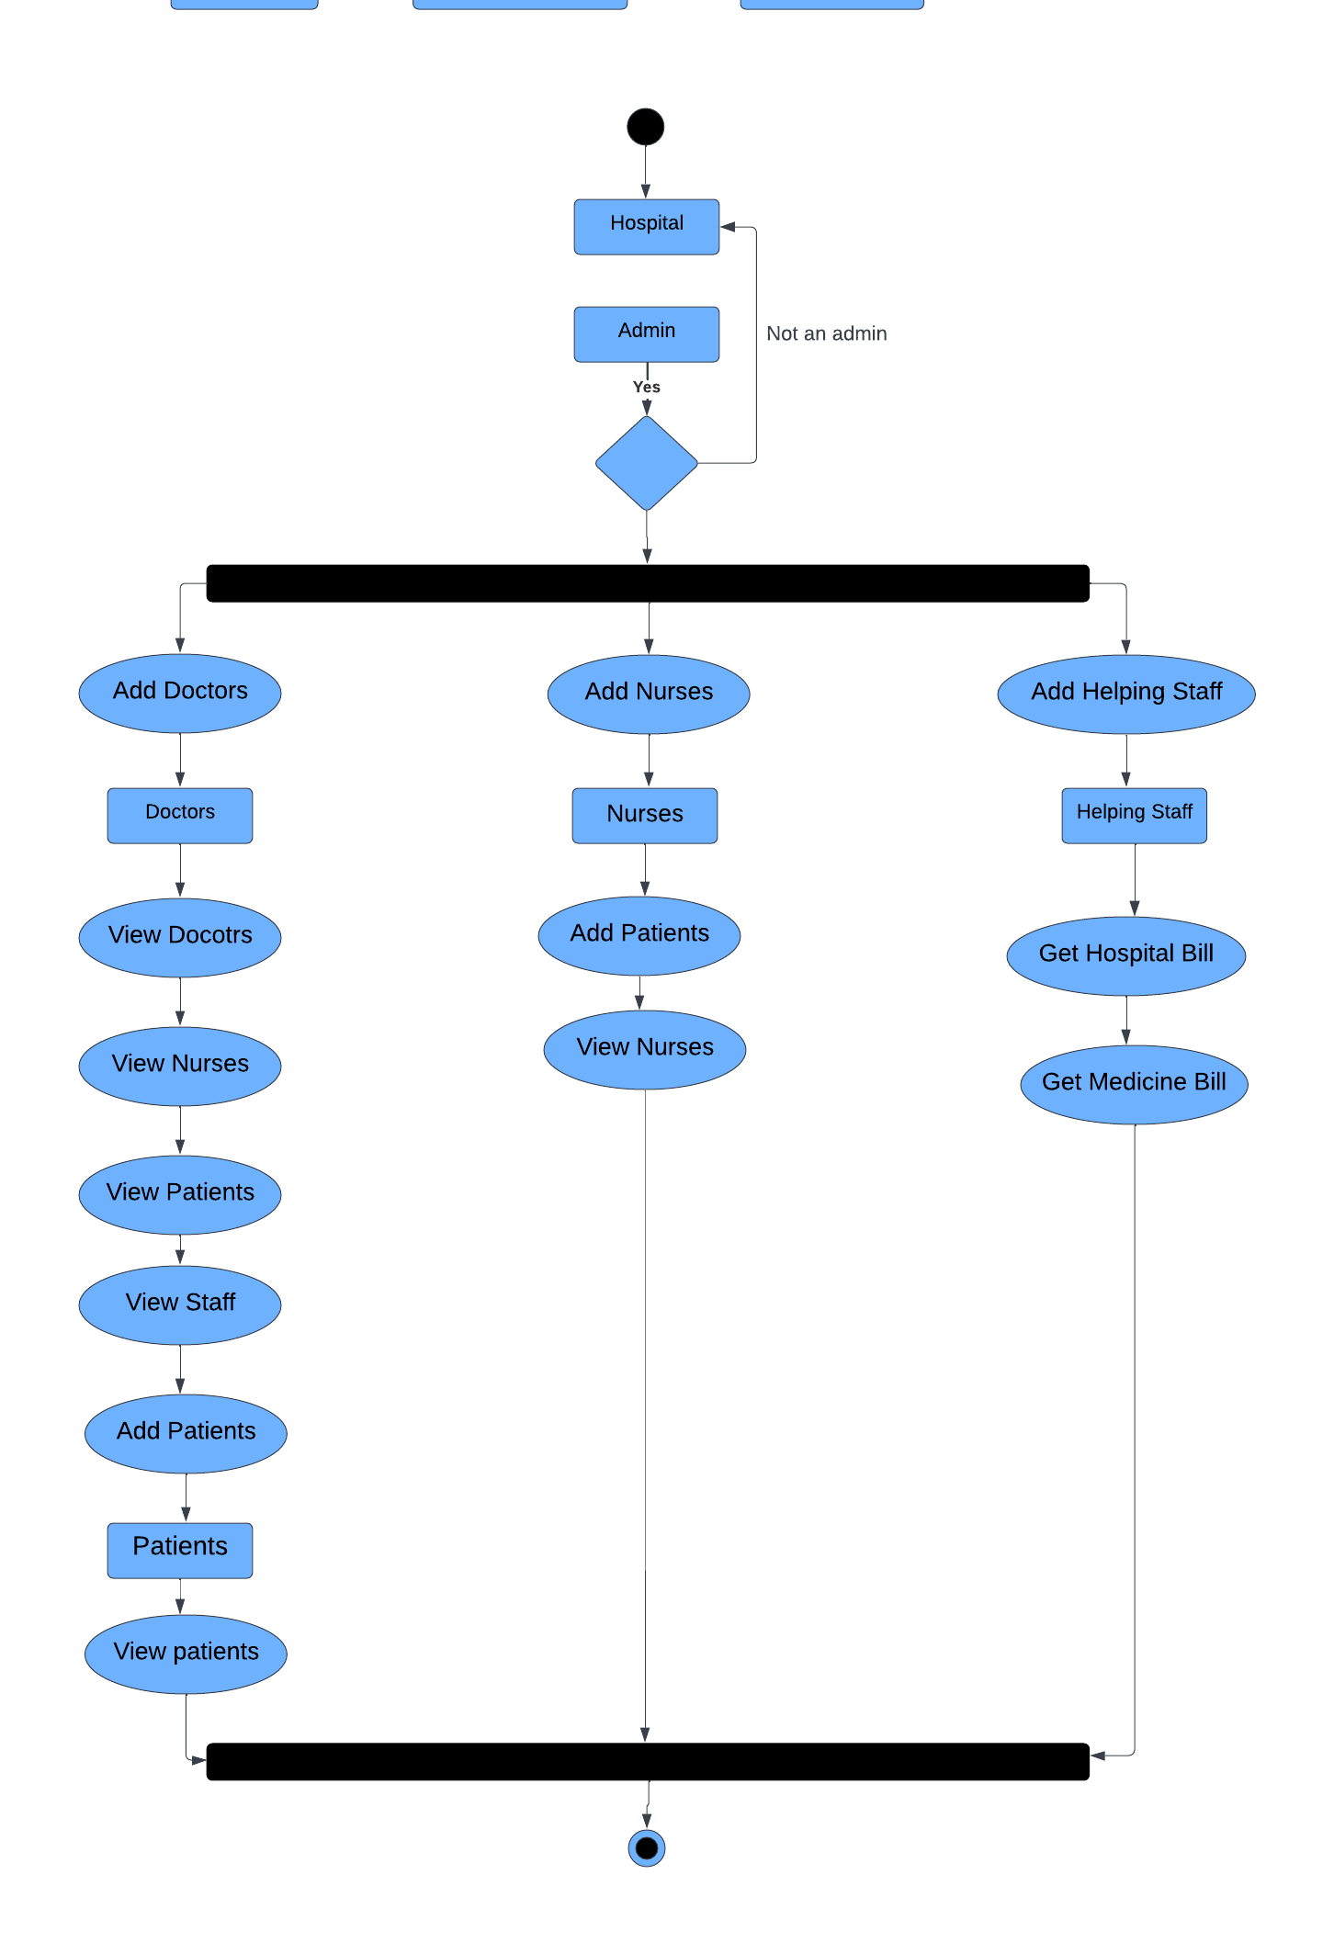

**5.4 data Flow Diagram**

**Level 0:**

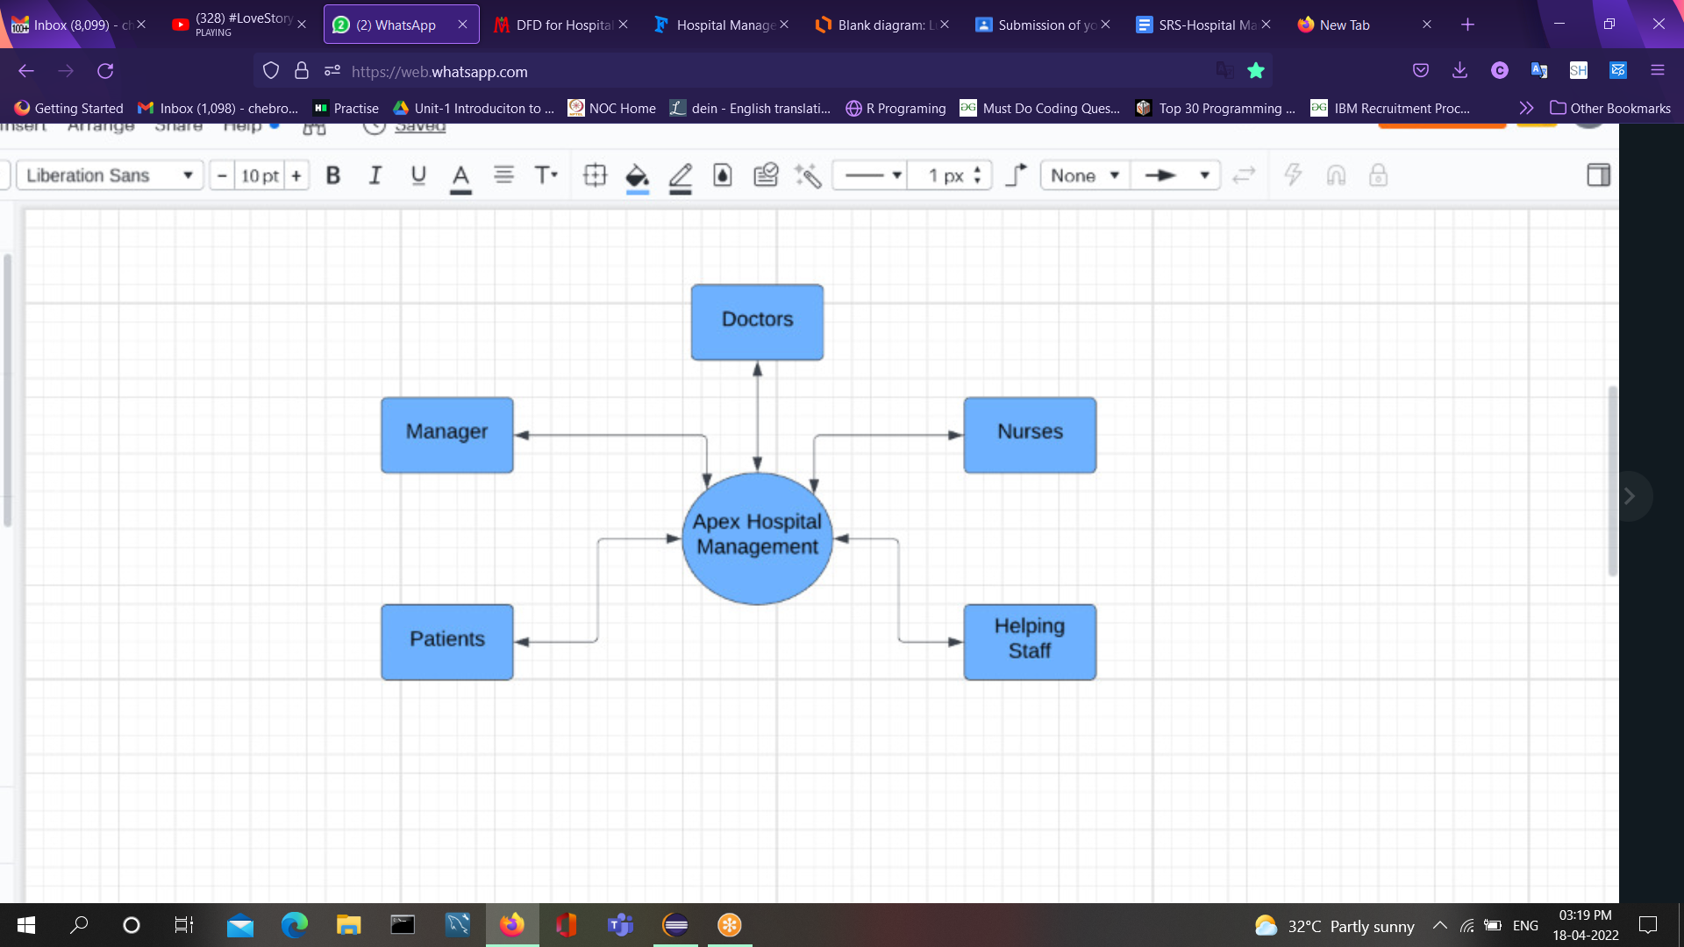

**Level 1:**

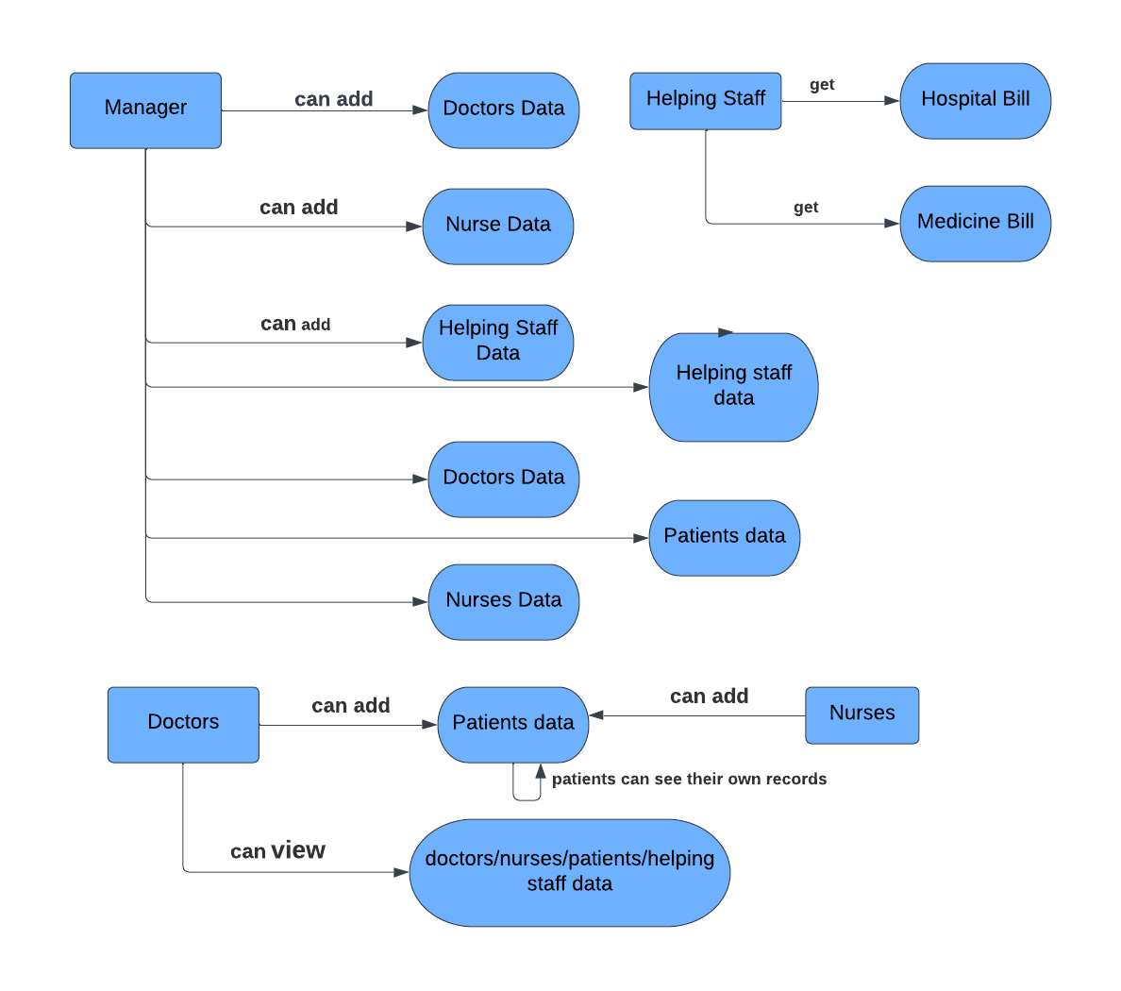

**5.5 State Chart Diagram**

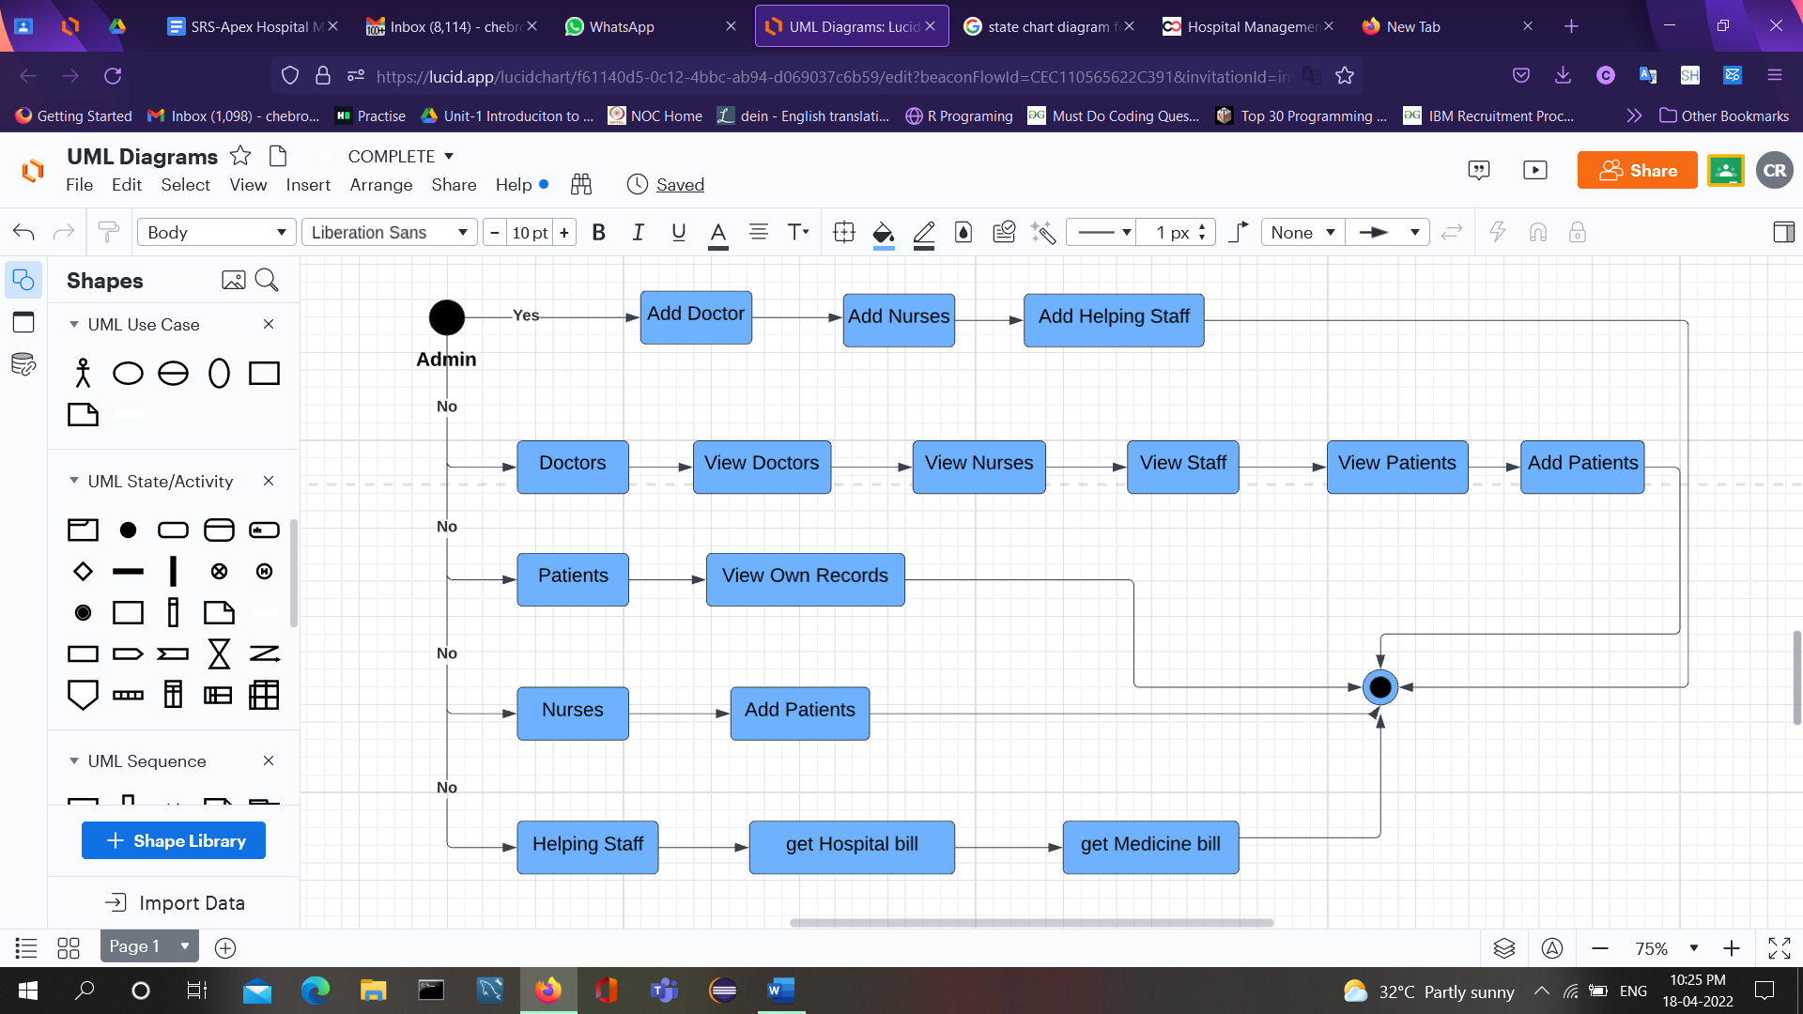

**6. Project Output Screenshots:**

**8. Conclusion**

In this project, we have implemented a hospital Management for Apex Hospital for user friendly and easy to maintain with the following features: Admin can add the doctors data, nurse data, helping staff data and view the details of doctors,patients,nurses,helping staff and patients, doctors can add patients data and can also see doctors data and can also view nurse and staff data. Helping staff will help with getting and adding medicine bills and also hospital bills. Nurses will be able to add patients' data. Patients can see their own data. This is user friendly system.

# 